Title: Simulated Drone Swarm Controller

Submitted by :
Nalli Tareni,
Christina Joseph,
Kannishkitha,
Sindhu Kamandla,
Sree Samhitha,
Onteddula Vamshi,
Rahul Patel,
Jiya Batra (Team Leader-jiya17batra@gmail.com)

Department:Computer Science and Engineering

Under the Guidance of: Saurabh Patil

Internship Organization: Defence Research and Development Organisation (DRDO-DYSL)

Internship Duration: April 2025 - June 2025
Date of Submission:

CONTENTS

Abstract
List of Tables
List of Figures
List of Abbreviations
CHAPTER 1: INTRODUCTION…………………………………………. 5
1.1 System Setup…….…………………………………………….…7 CHAPTER 2: ROS CORE CONCEPTS…………………………………11
2.1. Introduction………………………………………...……11
2.2. ROS Architecture Overview……………………………………11
2.3. Core Concepts ..
2.3.1. Nodes
2.3.2. Topics
2.3.3. Messages
2.3.4. Services
2.3.5. Parameters
CHAPTER 3: PX4 INTEGRATOR-MAVROS AND SITL INTEGRATION … 20
3.1. Using MAVROS with PX4
3.2. Connect PX4 STIL to ROS
3.3. Topic Testing
CHAPTER 4: MULTI-DRONE SETUP…………………………………... 24
4.1. Introduction……………………………………………..... 24
4.2. System Requirements…………………………………….. 24
4.3. Namespaces in ROS
4.4. TF Tree Management
4.5. Launch File Architecture
4.6. Visualization in RViz
4.7. Example Workflow
CHAPTER 5: Development of Node
5.1. Introduction to ROS Nodes
5.2. Advantages of ROS’s Modular Architecture
5.3. Understanding Nodes in ROS
5.4. ROS Topics: Communication Between Nodes
5.5. Publishers: Sending Messages on Topics
5.6. Subscribers: Receiving Messages from Topics
5.7. Installing ROS Noetic on Ubuntu:
5.8. Python Example: Simple Subscriber Node
5.9. C++ Example: Simple Publisher Node
5.10.C++ Example: Simple Subscriber Node
CHAPTER 6: SIMULATION………………27
6.1. Introduction……………………………….... 28
6.2. Tools and Technologies
6.3. Tasks Performed
CHAPTER 7: WEB INTERFACE INTEGRATOR………………………........ 29
7.1. Role Overview
7.2. Key Technologies
7.2.1. Flask(Python Web Framework)
7.2.2. Javascript and HTML
7.2.3. rosbridge_suite
7.2.4. roslibjs
7.3. Responsibilities and Tasks
7.4. Expected Challenges
7.5. Qualifications and Suitability for the Role…………………………29
CONCLUSION AND FUTURE SCOPE ..….………………………….. 34
BIBLIOGRAPHY……………………………………………………….. 35

ABSTRACT

ROS

The rapid advancement in robotics and autonomous systems is significantly driven by the Robot Operating System (ROS), which serves as a powerful middleware framework for developing robotic software. This document provides a comprehensive exploration of ROS, focusing on its architecture, core components, and the essential role it plays in facilitating communication among robotic systems.
The primary focus is on drone simulation using PX4 Software-In-The-Loop (SITL) and MAVROS integration, detailing the setup of multi-drone environments, namespace management, and data visualization in RViz. The document guides readers through the process of creating a robust drone swarm system, highlighting the tools and workflows necessary for coordinated autonomous flight.
Additionally, the document delves into the design and simulation of rocket motors, combining both 2D and 3
D modeling with experimental testing. A web interface is introduced to enable remote control and monitoring of drones and rockets, showcasing the integration of robotics, aerospace engineering, and web technologies. This comprehensive guide aims to inspire innovation and push the boundaries of autonomous systems, providing a valuable resource for researchers and practitioners in the field.

CHAPTER 1
INTRODUCTION

The world of robotics and autonomous systems is advancing at an unprecedented pace, and at the heart of this transformation lies the powerful Robot Operating System (ROS). This document explores the essential concepts of ROS, breaking down its architecture, core components, and the critical role it plays in enabling seamless communication between robotic systems. For readers eager to understand how software frameworks empower complex machines, this serves as an accessible yet technically rich starting point.

Building on this foundation, we dive into the exciting realm of drone simulation using PX4 SITL and MAVROS integration. From setting up multi-drone environments to managing namespaces and visualizing data in RViz, the document guides you through the process of creating a robust and scalable drone swarm system. Whether it’s for research, experimentation, or innovation, these sections highlight the tools and workflows needed to bring coordinated autonomous flight to life.

But the journey doesn’t end with drones. We also explore the fascinating design and simulation of rocket motors, combining 2D and 3D modeling with experimental testing. The final chapters introduce a web interface that brings all these elements together, allowing users to control and monitor drones and rockets remotely. By blending robotics, aerospace engineering, and web technologies, this document offers a comprehensive and inspiring guide to pushing the boundaries of autonomous systems.

Key Technologies :

PX4 SITL (Software-In-The-Loop):
PX4 is an open-source autopilot software. SITL mode allows PX4 to run as a simulation on a computer without requiring real drone hardware. This is ideal for testing and development since it replicates drone behavior virtually.

ROS (Robot Operating System):
ROS is a middleware framework that simplifies robot software development. It provides tools, libraries, and conventions for building complex robot behavior across multiple nodes. In this project, ROS manages the control logic, command flow, and communication between multiple simulated drones.

MAVROS:
MAVROS is a ROS package that communicates with the PX4 autopilot using the MAVLink protocol. It acts as a bridge, translating ROS messages to MAVLink commands that PX4 understands and vice versa. This integration is essential to let ROS-based swarm logic control PX4-based drones.

Purpose of This Architecture:
By combining PX4 SITL, ROS, and MAVROS, users can simulate complex drone swarm behaviors entirely on a computer. This reduces the risk, cost, and complexity of working with real hardware in the initial development phase.

1.1 System Setup

The installation and configuration process required to prepare the environment for multi-drone simulation.

1. Installing ROS and Setting Up a Catkin Workspace:
Install a compatible ROS version (e.g., ROS Noetic or ROS Melodic, depending on the OS).
Create a catkin workspace (~/catkin_ws), which is the standard build system for ROS packages.
Build and source the workspace so new packages like MAVROS can be added later.

2. Installing MAVROS:
Install MAVROS using ROS package tools or build it from source.
Install geographiclib datasets (required for MAVROS to provide position data).
Test that MAVROS is installed and can launch nodes that communicate over MAVLink.

3. Setting Up PX4 Autopilot for SITL:
Clone the PX4-Autopilot GitHub repository.
Install the required dependencies using the PX4 setup scripts.
Build PX4 for SITL (targeted simulation) using make px4_sitl_default.
Choose a simulator like JMAVSim (lightweight and fast) or Gazebo (3D environment with obstacles).

4. Running the Simulation:
Launch PX4 in SITL mode with the chosen simulator.
Start MAVROS to begin communication with PX4 over a designated UDP or TCP port.

5. Testing the PX4–ROS Connection:
Use a rostopic list to verify active topics (e.g., /mavros/state, /mavros/local_position/pose).
Use rqt_graph to visualize how ROS nodes and topics are interconnected, ensuring proper communication between PX4 and ROS.

6. Adding Environment Variables:
Update the .bashrc file with environment variables like ROS workspace paths, simulator aliases, or PX4 model settings for convenience.
Source .bashrc after changes to apply the configuration.

Outcome:
By completing this setup, you will have a fully operational simulation environment that allows you to develop, test, and iterate on drone swarm algorithms using ROS and PX4.

CHAPTER 2
ROS CORE CONCEPTS

2.1. Introduction to ROS
Robot Operating System (ROS) is an open-source middleware suite used to build robotic software systems. It provides the framework to handle communication, coordination, and control between various robot components.
ROS is not a traditional operating system; instead, it runs on top of Linux (Ubuntu is the most common) and supports distributed computing for robots.

2.2. ROS Architecture Overview
ROS works on a publish/subscribe and request/response architecture involving multiple processes (called nodes) that interact via:
- Topics for data streaming
- Services for synchronous communication
- Actions for long-duration tasks
- Parameters for configuration
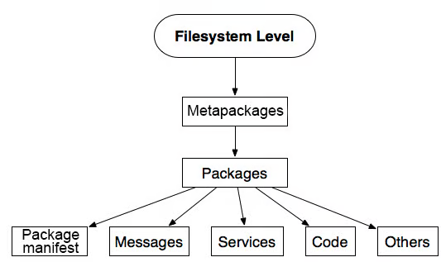

2.3. Core Concepts

2.3.1 Nodes
Definition:
A node is an executable that uses ROS to communicate with other nodes.
Key Points:
- Nodes are the basic units of computation in ROS.
- Each node should be small and focused on a specific task.
- Nodes communicate using topics, services, and actions.
Example:
- A node named /camera_node might publish image data.
- A node named /image_processor might subscribe to that data to perform image recognition.
Command Example:
rosrun package_name node_name

2.3.2 Topics
Definition:
A topic is a named bus over which nodes exchange messages using a publish/subscribe model.
Key Points:
- Used for unidirectional, many-to-many communication.
- Nodes publish messages to a topic, and other nodes subscribe to receive those messages.
Common Use-Cases:
- Publishing sensor data like /laser_scan, /camera/image_raw.
- Subscribing to motor commands like /cmd_vel.
Command Examples:
rostopic list
rostopic echo /topic_name

2.3.3 Messages
Definition:
A message is a simple data structure used to exchange information between nodes.
Key Points:
- Defined in .msg files inside a ROS package.
- Can contain primitive types (int, float, string) and nested message types.
Example Message Format (std_msgs/String.msg):
string data
Example Usage:
rostopic pub /chatter std_msgs/String "data: 'Hello, ROS'"

2.3.4 Services
Definition:
A service is a synchronous communication mechanism using a request/response model.
Key Points:
- Ideal for tasks that need a response (e.g., requesting robot status).
- Defined using .srv files with request and response structures.
Example Service Definition (AddTwoInts.srv):
int64 a
int64 b
---
int64 sum
Command Examples:
rosservice list
rosservice call /add_two_ints 5 6

2.3.5 Parameters
Definition:
Parameters are used to store static or runtime configuration values in the Parameter Server.
Key Points:
- Can store integers, floats, strings, lists, and dictionaries.
- Accessible by all nodes in the system.
Common Usage:
- Setting PID controller values.
- Specifying file paths or robot model settings.
Command Examples:
rosparam set /robot_speed 1.5
rosparam get /robot_speed
rosparam list

4. Conclusion
Understanding the core concepts of ROS — Nodes, Topics, Services, Messages, and Parameters — is essential for building scalable and maintainable robotic systems. These components together enable modularity, communication, and configurability in real-time robotic applications.

CHAPTER 3
PX4 INTEGRATOR-MAVROS AND SITL INTEGRATION

3.1. Using MAVROS with PX4

What is MAVROS?

MAVROS is a ROS package that acts as a communication bridge between PX4 (which uses MAVLink) and the ROS ecosystem. It allows developers to access PX4 telemetry, control commands, and parameters using ROS topics, services, and actions.

Installation of MAVROS

Ensure ROS is installed (preferably ROS Noetic or Humble, based on your setup), then install MAVROS using the following commands:

Bash

sudo apt update
sudo apt install ros-noetic-mavros ros-noetic-mavros-extras
Also install the MAVLink message definitions:

Bash

sudo apt install ros-noetic-mavlink

Initialize geographic data for MAVROS:

Bash

wget https://raw.githubusercontent.com/mavlink/mavros/master/mavros/scripts/install_geographiclib_datasets.sh
sudo bash install_geographiclib_datasets.sh
Launching MAVROS

After installation, MAVROS can be launched using:

Bash

roslaunch mavros px4.launch
Make sure the fcu_url is correctly set to communicate with PX4 SITL, typically:

udp://:14540@localhost:14557

3.2. Connecting PX4 SITL to ROS

Starting PX4 SITL

Navigate to the PX4 Firmware directory and start the PX4 SITL:

Bash

cd ~/PX4-Autopilot
make px4_sitl_default
To run it with Gazebo:

Bash

make px4_sitl_default gazebo
This will start a simulated drone using PX4 with UDP ports open for MAVLink communication.

Connecting to MAVROS

Ensure MAVROS connects to the PX4 SITL by launching:

Bash

roslaunch mavros px4.launch fcu_url:="udp://:14540@localhost:14557"
You should see output indicating a successful connection (e.g., "FCU: Connected", "Home position initialized", etc.).

3.3. Topic Testing

Once MAVROS is running, you can explore active topics using:
```bash
rostopic list
Important Topics:

/mavros/state – Drone state (armed, connected, mode)
/mavros/local_position/pose – Current position in local frame
/mavros/setpoint_position/local – Topic to command position
Example: Echoing a Topic

To see the drone's current position:

Bash

rostopic echo /mavros/local_position/pose
Example: Publishing a Setpoint

To move the drone in simulation, first send setpoints continuously in OFFBOARD mode:

Bash
rostopic pub -r 10 /mavros/setpoint_position/local geometry_msgs/PoseStamped "header
CHAPTER 4
MULTI-DRONE SETUP USING ROS

4.1. Introduction
Operating multiple drones (UAVs) in the same ROS environment presents challenges such as data collisions, conflicting topics, and shared transformations. This project explains how to overcome these issues using ROS best practices like namespaces, TF frames, and modular launch files.

4.2. System Requirements
- Operating System: Ubuntu (20.04 or similar)
- ROS Distribution: ROS Noetic or ROS 2 Foxy
- Hardware: Compatible drone platforms (e.g., Crazyflie 2.0, PX4 with Gazebo)
- Simulation (optional): Gazebo or RViz

4.3. Namespaces in ROS
Purpose:
Namespaces isolate each drone’s ROS topics, services, and parameters to prevent overlap and interference.
Example Structure:
/drone1/cmd_vel
/drone1/odom
/drone2/cmd_vel
/drone2/odom
Implementation:
Use <group> and ns in launch files:
<group ns="drone1">
<node pkg="drone_controller" type="controller_node" name="controller"/>
</group>

<group ns="drone2">
<node pkg="drone_controller" type="controller_node" name="controller"/>
</group>

4.4. TF Tree Management
Challenge:
Each drone broadcasts TFs like /base_link -> /odom, which must be unique per drone.
Solution:
Prefix TFs with the drone namespace or a unique ID.
Example:
/drone1/odom -> /drone1/base_link
/drone2/odom -> /drone2/base_link
Tools:
Use tf_prefix (ROS 1) or static_transform_publisher (ROS 2) with namespaces.
URDF Adjustment:
In your URDF or Xacro:
<robot name="$(arg drone_name)_robot">
<link name="$(arg drone_name)_base_link"/>
</robot>

4.5. Launch File Architecture
Master Launch File:
A central launch file starts multiple drones.
<launch>
<include file="$(find multi_drone)/launch/single_drone.launch">
<arg name="drone_id" value="drone1"/>
</include>
<include file="$(find multi_drone)/launch/single_drone.launch">
<arg name="drone_id" value="drone2"/>
</include>
</launch>
Single Drone Launch File:
Handles one drone with parameterized ID.
<launch>
<arg name="drone_id" default="drone1"/>
<group ns="$(arg drone_id)">
<node pkg="drone_bringup" type="state_publisher" name="state_pub"/>
<node pkg="drone_bringup" type="controller_node" name="controller"/>
</group>
</launch>

4.6. Visualization in RViz
Use separate TF namespaces and tf_prefix to correctly visualize all drones without overlapping TF trees. Use markers or unique robot models.

4.7. Example Workflow
1. Set up drone URDF/Xacro with unique frame names.
2. Create launch files with proper namespaces and arguments.
3. Run the master launch to bring up all drones.
4. Use RViz to visualize individual TF trees.
5. Test communication between drones using inter-robot coordination nodes (optional).

8. Additional Considerations

- Synchronization: Use ROS Time for log synchronization.
- Communication: Ensure inter-drone communication uses a shared topic or relay node.
- Simulation: Gazebo supports spawning multiple drones using SDF/URDF with unique namespaces.

CHAPTER 5
Development of Node

5.1. Introduction to ROS Nodes
ROS nodes are the fundamental, self-contained units of computation in the Robot Operating System. Each node is a standalone program designed to perform a specific task within a robotic system, such as sensor data acquisition, motor control, or path planning. Running as independent processes, nodes communicate with each other using ROS's communication infrastructure, primarily through asynchronous message passing on named topics and synchronous request-response interactions via services.

5.2. Advantages of ROS’s Modular Architecture
This modular and distributed architecture offers significant advantages, including enhanced robustness (as the failure of one node doesn't necessarily affect others), increased reusability of software components across different robotic platforms, and simplified development and debugging of complex robotic systems. By breaking down intricate functionalities into manageable nodes, ROS facilitates collaboration among developers and enables the creation of sophisticated and adaptable robot applications.

5.3. Understanding Nodes in ROS
Imagine a robot as having different "organs" or "specialists," each responsible for a specific job. In ROS, each of these specialized programs is called a node. A node is essentially an executable program that runs independently and performs a particular task. For example, you might have a node that controls the robot's camera, another that processes sensor data, and yet another that controls the motors.

Think of a node as a self-contained software module. It has its own logic, performs its specific computations, and interacts with the rest of the ROS system. The beauty of nodes is their modularity: you can develop, test, and debug them individually. If one node happens to crash, it doesn't necessarily bring down the entire robot system, as other nodes can continue to run.
5.4. ROS Topics: Communication Between Nodes
Now, how do these individual nodes communicate and share information? That's where topics come in. Think of a topic as a named message bus or a channel of communication. When a node has some data to share (like the camera node capturing an image), it can publish that data as a message onto a specific topic (e.g., "/camera/image_raw").

Other nodes that are interested in this type of data can subscribe to that same topic. Whenever a new message is published on that topic, all the subscribing nodes will receive it. This is a one-to-many or many-to-many communication style, where multiple publishers can send data to a topic, and multiple subscribers can receive it. The nodes don't need to know anything about each other directly; they only need to know the name and type of the topic they are interested in.

5.5. Publishers: Sending Messages on Topics
A publisher is a node that creates and sends messages onto a specific topic. The camera node we mentioned earlier would be a publisher on the "/camera/image_raw" topic. Its job is to continuously capture images from the camera and package them into ROS messages of a specific type (e.g., sensor_msgs/Image) and then broadcast these messages onto the topic.

A single node can be a publisher on multiple topics, sending out different kinds of information. For instance, a sensor processing node might publish processed sensor readings on one topic and diagnostic information on another.

5.6. Subscribers: Receiving Messages from Topics
A subscriber is a node that listens for and receives messages published on a specific topic. For example, a navigation node might subscribe to the "/camera/image_raw" topic to get visual information about its surroundings. Whenever the camera node (the publisher) sends out a new image message, the navigation node (the subscriber) will receive it and can then use that information for tasks like obstacle avoidance or localization.

Just like publishers, a single node can be a subscriber to multiple topics, gathering different pieces of information from various parts of the system. A robot control node, for instance, might subscribe to sensor data topics, path planning topics, and even user command topics to make informed decisions about the robot's actions.

In essence:
Nodes are the workers, each doing a specific job.
Topics are the public channels where workers can share information.
Publishers are the workers who put information onto these channels.
Subscribers are the workers who listen to these channels to receive the information they need.

5.7. Installing ROS Noetic on Ubuntu:
Step 1: Set Up Your Sources List
Open a terminal (Ctrl + Alt + T).

Set up your system to accept software from packages.ros.org by adding the ROS repository to your sources list. Run the following command:

bash
Run
Copy code
sudo sh -c 'echo "deb http://packages.ros.org/ros/ubuntu $(lsb_release -cs) main" > /etc/apt/sources.list.d/ros-latest.list'
Step 2: Set Up Your Keys
Add the ROS package repository key:

bash
Run
Copy code
sudo apt-key adv --keyserver 'hkp://keyserver.ubuntu.com:80' --recv-key F42ED6FBAB17C654
Step 3: Update Your Package Index
Update your package index to include the new repository:

bash
Run
Copy code
sudo apt update
Step 4: Install ROS Noetic
Install the full desktop version of ROS Noetic (this includes ROS, RViz, and other tools):

bash
Run
Copy code
sudo apt install ros-noetic-desktop-full
Alternatively, if you want a more minimal installation, you can install the base version:

bash
Run
Copy code
sudo apt install ros-noetic-ros-base
Step 5: Initialize rosdep
Initialize rosdep, which is a tool for managing dependencies:

bash
Run
Copy code
sudo rosdep init
rosdep update
Step 6: Environment Setup
Set up your environment by adding the ROS environment variables to your bash session. You can do this by adding the following line to your ~/.bashrc file:

bash
Run
Copy code
echo "source /opt/ros/noetic/setup.bash" >> ~/.bashrc
Source your updated ~/.bashrc:

bash
Run
Copy code
source ~/.bashrc
Step 7: Install Additional Dependencies
Install additional dependencies for building packages:

bash
Run
Copy code
sudo apt install python3-rosinstall python3-rosinstall-generator python3-wstool build-essential
Step 8: Create and Build Your Catkin Workspace (Optional)
Create a catkin workspace (if you plan to develop your own packages):

bash
Run
Copy code
mkdir -p ~/catkin_ws/src
cd ~/catkin_ws/
catkin_make
Source your workspace:

bash
Run
Copy code
source devel/setup.bash
Step 9: Verify the Installation
Check if ROS is installed correctly by running:

bash
Run
Copy code
roscore
This should start the ROS master, and you should see output indicating that it is running.

Step 10: Install Additional Packages (Optional)
You can install additional ROS packages as needed using apt or rosdep. For example, to install the turtlebot3 package, you would run:

bash
Run
Copy code
sudo apt install ros-noetic-turtlebot3

5.8. Python Example: Simple Subscriber Node
File: listener.py

python
Copy
Edit
#!/usr/bin/env python

import rospy
from std_msgs.msg import String

def callback(data):
rospy.loginfo(rospy.get_caller_id() + " I heard %s", data.data)

def listener():
rospy.init_node('listener_node', anonymous=True)
rospy.Subscriber('chatter', String, callback)
rospy.spin()

if __name__ == '__main__':
listener()
Explanation:

rospy.Subscriber('chatter', String, callback) → subscribes to chatter topic

callback → called when message arrives

rospy.spin() → keeps Python from exiting

Make Python files executable
bash
Copy
Edit
chmod +x talker.py listener.py
Run nodes
bash
Copy
Edit
roscore
rosrun my_custom_package talker.py
rosrun my_custom_package listener.py

5.9. C++ Example: Simple Publisher Node
File: talker.cpp

cpp
Copy
Edit
#include "ros/ros.h"
#include "std_msgs/String.h"
#include <sstream>

int main(int argc, char **argv)
{
ros::init(argc, argv, "talker_node");
ros::NodeHandle n;
ros::Publisher chatter_pub = n.advertise<std_msgs::String>("chatter", 1000);
ros::Rate loop_rate(1);

while (ros::ok())
{
std_msgs::String msg;
std::stringstream ss;
ss << "Hello ROS at " << ros::Time::now();
msg.data = ss.str();

ROS_INFO("%s", msg.data.c_str());
chatter_pub.publish(msg);

ros::spinOnce();
loop_rate.sleep();
}

return 0;
}

5.10.C++ Example: Simple Subscriber Node
File: listener.cpp

cpp
Copy
Edit
#include "ros/ros.h"
#include "std_msgs/String.h"

void chatterCallback(const std_msgs::String::ConstPtr& msg)
{
ROS_INFO("I heard: [%s]", msg->data.c_str());
}

int main(int argc, char **argv)
{
ros::init(argc, argv, "listener_node");
ros::NodeHandle n;

ros::Subscriber sub = n.subscribe("chatter", 1000, chatterCallback);
ros::spin();
return 0;
}
Update CMakeLists.txt
Inside add_executable() and target_link_libraries():

cmake
Copy
Edit
add_executable(talker_node src/talker.cpp)
target_link_libraries(talker_node ${catkin_LIBRARIES})
add_executable(listener_node src/listener.cpp)
target_link_libraries(listener_node ${catkin_LIBRARIES})
Build the package
bash
Copy
Edit
cd ~/catkin_ws
catkin_make
source devel/setup.bash
Run C++ nodes
bash
Copy
Edit
roscore
rosrun my_custom_package talker_node
rosrun my_custom_package listener_node

CHAPTER 6
SIMULATION
INTRODUCTION
The simulator specialist work is, configure and demonstrate the simulation of drones in the Gazebo environment, use RViz for visualization of data, and conduct drone formation simulations. These are important task for testing system behaviour in a simulated environment prior to deployment.
TOOLS AND TECHNOLOGIES
· Gazebo – For simulating the environment of drones
· RViz – For visualization of sensor data and transformations
· ROS Noetic – Robot Operating System platform
· PX4 Autopilot – Drone firmware
· Ubuntu 20.04 – Operating System
TASKS PERFORMED
- Simulation in Gazebo:
· Set up the Gazebo environment.
· Loaded and started the drone model.
· Confirmed simulation responsiveness and physics.
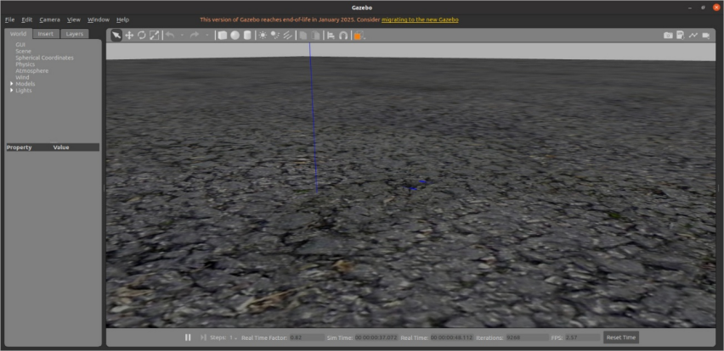
Figure 1: Starting the Gazebo simulation environment
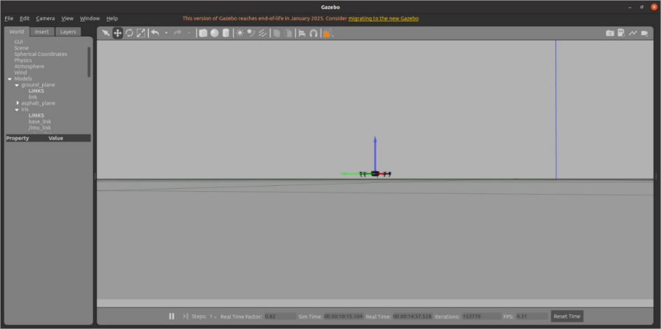
Figure 2: Drone model loaded successfully in Gazebo
- RViz Usage
· Started RViz to display sensor and positional data.
· Verified topic publications, transforms, and drone position.
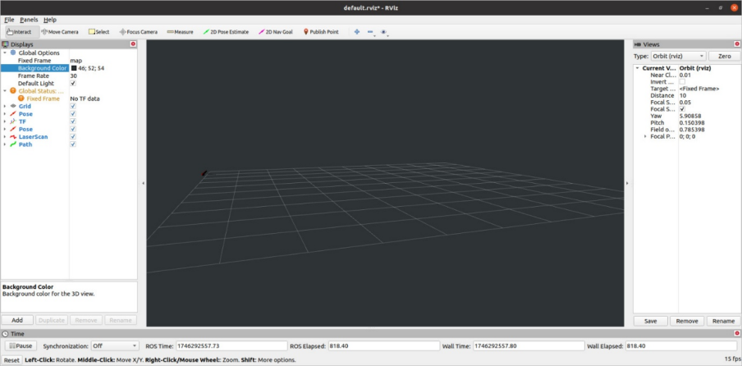
Figure 3: RViz environment with drone data and model view
- Drone Formation Simulation
· Added multiple drone spawns in Gazebo.
· Created simple drone formations and observed behaviour.
· Tested inter-drone distance and orientation in simulation
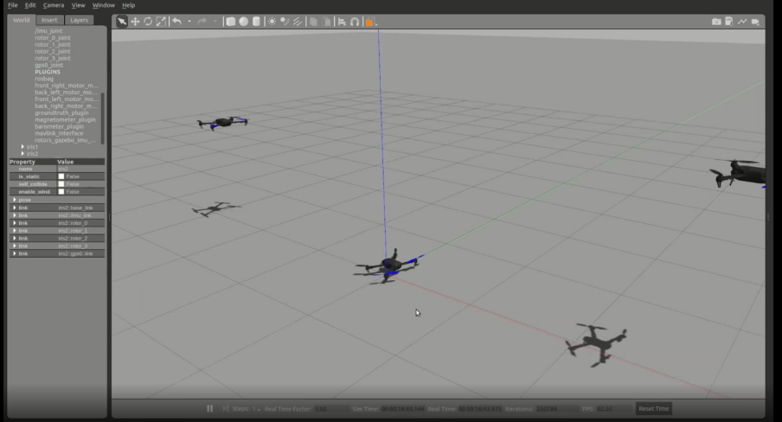
Figure 4: Multiple drones in formation within Gazebo
CHALLENGES
· Incompatibility between ROS and PX4 versions.
· Tuning parameters for realistic drone dynamics.
· RViz setup for multiple frames and namespaces.
OUTCOMES
· Successfully executed Gazebo simulations.
· Visualized sensor data and drones with Rviz.
· Displayed drone formations.

CHAPTER 7
WEB INTERFACE INTEGRATOR

7.1. Role Overview
As the Web Interface Integrator, the primary responsibility is to develop a seamless connection between the ROS-based drone simulation environment and a user-friendly web interface. This role ensures real-time interaction, control, and visualization of drone data via web technologies, providing an accessible front end to the complex ROS backend system.

7.2. Key Technologies

7.2.1 Flask (Python Web Framework)
Flask is a lightweight Python web framework used to set up the backend server. It allows the development of RESTful endpoints or full web applications that serve HTML pages, connect to ROS processes, and serve data to the front end.

7.2.2 JavaScript and HTML
JavaScript and HTML are essential for frontend development. HTML structures the webpage while JavaScript enables interactive and dynamic content, such as visualizations of drone positions, telemetry, or system status.

7.2.3 rosbridge_suite
rosbridge_suite is a ROS package that enables ROS to communicate over WebSockets. It exposes ROS topics, services, and parameters so that non-ROS systems, like browser-based applications, can interact with them in real time.

7.2.4 roslibjs
roslibjs is a JavaScript library that communicates with rosbridge_suite over WebSockets. It allows web pages to publish to ROS topics, subscribe to topics, call services, and interact with ROS parameters using JavaScript.

7.3. Responsibilities and Tasks
• Set up Flask server to interface with ROS and serve frontend content.
• Configure and launch rosbridge_suite to enable WebSocket communication.
• Develop frontend interface using HTML/JavaScript.
• Integrate roslibjs to subscribe/publish to ROS topics.
• Enable real-time display of drone telemetry, position, and system state.
• Coordinate with simulation and PX4 integration teams to ensure accurate data flow.

7.4. Expected Challenges
• Ensuring real-time performance and low latency data exchange between ROS and browser.
• Handling message formats and synchronizing data visualization.
• Debugging WebSocket connections or CORS-related browser issues.
• Coordinating topic/service names and data structures across simulation, ROS, and frontend code.

7.5. Qualifications and Suitability for the Role
With a strong foundation in JavaScript, HTML, CSS, and Python, and experience working on full-stack web applications, I am well-prepared for the role of Web Interface Integrator. My ongoing involvement in PX4 and ROS-based simulation projects gives me practical insight into the system’s architecture and communication flow. Additionally, my teamwork, leadership, and problem-solving skills allow me to coordinate effectively across different sections of the project.

6. References

Chapter 2 ref:
· Official ROS Wiki: http://wiki.ros.org
· ROS Tutorials: http://wiki.ros.org/ROS/Tutorials

Chapter 4: References
- Hönig, W., & Ayanian, N. (2017). *Flying Multiple UAVs Using ROS*. https://whoenig.github.io/publications/2017_Springer_Hoenig.pdf
- ROS Wiki: http://wiki.ros.org
- TF in Multi-Robot Setup: https://discourse.ros.org/t/tf-tree-in-a-multi-robot-setup-in-ros2/41426
Chapter 6:REFERENCES
· ROS Wiki (wiki.ros.org)
· PX4 Autopilot Docs
· Gazebo Tutorials

Chapter 7:ref
• PX4 Autopilot Documentation – https://docs.px4.io/
• ROS Wiki – http://wiki.ros.org/
• rosbridge_suite GitHub – https://github.com/RobotWebTools/rosbridge_suite
• roslibjs GitHub – https://github.com/RobotWebTools/roslibjs
• Flask Documentation – https://flask.palletsprojects.com/

8.CONCLUSION AND FUTURE SCOPE

In conclusion, the integration of ROS, PX4, and MAVROS has proven to be a powerful framework for developing and simulating drone systems. This project has successfully demonstrated the capabilities of ROS in managing complex multi-drone environments, facilitating seamless communication between nodes, and enabling real-time data visualization through tools like RViz. The modular architecture of ROS allows for the easy development and testing of individual components, enhancing the robustness and scalability of robotic applications.
The successful implementation of drone simulations in Gazebo has provided valuable insights into the dynamics of drone behavior and formation flying, paving the way for further research and experimentation. The web interface developed for real-time interaction with the drone simulation environment exemplifies the potential of combining robotics with web technologies, making advanced robotic systems more accessible to users.
Looking ahead, there are several avenues for future work. Enhancements could include:
- Advanced Algorithms: Implementing more sophisticated algorithms for autonomous navigation, obstacle avoidance, and swarm intelligence to improve the efficiency and reliability of drone operations.
- Real-World Testing: Transitioning from simulation to real-world applications by conducting field tests with physical drones, which would provide insights into the challenges and limitations of the current system.
- Inter-Drone Communication: Developing robust communication protocols for inter-drone coordination, enabling collaborative tasks and improved swarm behavior.
- Integration with Other Technologies: Exploring the integration of artificial intelligence and machine learning techniques to enhance decision-making processes and adapt to dynamic environments.
- User Interface Improvements: Further refining the web interface to include more interactive features, such as live telemetry data visualization, mission planning tools, and user-friendly controls for drone operations.
By pursuing these future directions, the project can contribute significantly to the field of autonomous systems, fostering innovation and expanding the capabilities of drone technology in various applications, including search and rescue, agriculture, surveillance, and environmental monitoring.

BIBLIOGRAPHY
- Official ROS Wiki. (n.d.). Retrieved from http://wiki.ros.org
- ROS Tutorials. (n.d.). Retrieved from http://wiki.ros.org/ROS/Tutorials
- Hönig, W., & Ayanian, N. (2017). Flying Multiple UAVs Using ROS. Retrieved from https://whoenig.github.io/publications/2017_Springer_Hoenig.pdf
- TF in Multi-Robot Setup. (2020). Retrieved from https://discourse.ros.org/t/tf-tree-in-a-multi-robot-setup-in-ros2/41426
- PX4 Autopilot Documentation. (n.d.). Retrieved from https://docs.px4.io/
- Gazebo Tutorials. (n.d.). Retrieved from http://gazebosim.org/tutorials
- rosbridge_suite GitHub. (n.d.). Retrieved from https://github.com/RobotWebTools/rosbridge_suite
- roslibjs GitHub. (n.d.). Retrieved from https://github.com/RobotWebTools/roslibjs
- Flask Documentation. (n.d.). Retrieved from https://flask.palletsprojects.com/
- PX4 Autopilot Docs. (n.d.). Retrieved from https://docs.px4.io/
This bibliography includes key resources and references that were utilized throughout the project, providing foundational knowledge and guidance on ROS, PX4, MAVROS, and related technologies.

- Official ROS Wiki. (n.d.). Retrieved from http://wiki.ros.org
- ROS Tutorials. (n.d.). Retrieved from http://wiki.ros.org/ROS/Tutorials
- Hönig, W., & Ayanian, N. (2017). Flying Multiple UAVs Using ROS. Retrieved from https://whoenig.github.io/publications/2017_Springer_Hoenig.pdf
- TF in Multi-Robot Setup. (2020). Retrieved from https://discourse.ros.org/t/tf-tree-in-a-multi-robot-setup-in-ros2/41426
- PX4 Autopilot Documentation. (n.d.). Retrieved from https://docs.px4.io/
- Gazebo Tutorials. (n.d.). Retrieved from http://gazebosim.org/tutorials
- rosbridge_suite GitHub. (n.d.). Retrieved from https://github.com/RobotWebTools/rosbridge_suite
- roslibjs GitHub. (n.d.). Retrieved from https://github.com/RobotWebTools/roslibjs
- Flask Documentation. (n.d.). Retrieved from https://flask.palletsprojects.com/
- PX4 Autopilot Docs. (n.d.). Retrieved from https://docs.px4.io/
This bibliography includes key resources and references that were utilized throughout the project, providing foundational knowledge and guidance on ROS, PX4, MAVROS, and related technologies.

